SUMMERVILLE CREDIT UNION · CONSOLIDATED MEMBER GUIDE · CSUM-13 of 30
Wire Transfers — Domestic & International

Module: nFinia Digital Banking > Move Money > Wire Transfer
Sources: Summerville Reports Series A (36 docs) + Series B (25 docs) | Features: nFinia Documentation Features Spreadsheet
01 PRODUCT SUMMARY

Summerville Credit Union offers both Domestic and International Outgoing Wire Transfers through the nFinia digital banking platform. Wire transfers are the preferred instrument for time-critical, high-value payments that require same-day or guaranteed settlement — real estate closings, escrow deposits, large business disbursements, and international supplier payments.
Domestic wires clear through the Federal Reserve Fedwire system and typically settle the same business day when submitted before the daily cut-off time. International wires route through the SWIFT network and typically settle within 1–3 international banking days, with additional time for correspondent bank processing.
Wire transfers are captured as digital forms within the Online Forms portal. The system pre-populates available account information and guides members through all required fields. For international wires, a SWIFT/BIC code for the receiving bank is mandatory, as is a complete international beneficiary address.

At a Glance

Attribute | Detail
Module | Move Money > Online Forms > Wire Transfer
Domestic Network | Federal Reserve Fedwire
International Network | SWIFT
Domestic Settlement | Same business day (if before cut-off)
International Settlement | 1–3 international banking days
Related Reports | CSUM-06 (Move Money Hub), CSUM-11 (Recipient Management), CSUM-19 (Online Forms)

02 KEY USE CASES

Use Case | Who Uses It | What They Do | Business Value
Real Estate Closing | Members wiring earnest money or closing funds | Complete domestic wire form with title company's bank details | Same-day settlement meets real estate transaction deadlines
International Supplier Payment | Business members paying overseas vendors | Complete international wire form with SWIFT, IBAN, and beneficiary address | SWIFT network reaches most global financial institutions
Recurring Wire Payee | Members who wire to the same beneficiary regularly | Save recipient in Recipient Management; use template for repeat wires | Reduces data entry errors for known beneficiaries
High-Value Urgent Payment | Members needing same-day guaranteed settlement | Use wire instead of ACH for amount-critical same-day needs | ACH cannot guarantee same-day; wire settles by end of business day

03 STEP-BY-STEP GUIDE

Navigation: Dashboard > Move Money > Online Forms > Wire Transfer Form.
Step 1 — Start from Dashboard
The member begins at the Dashboard after logging in. The Dashboard displays all account balances, upcoming payments, quick-action tiles, and the top navigation bar with links to Accounts, Move Money, and More.
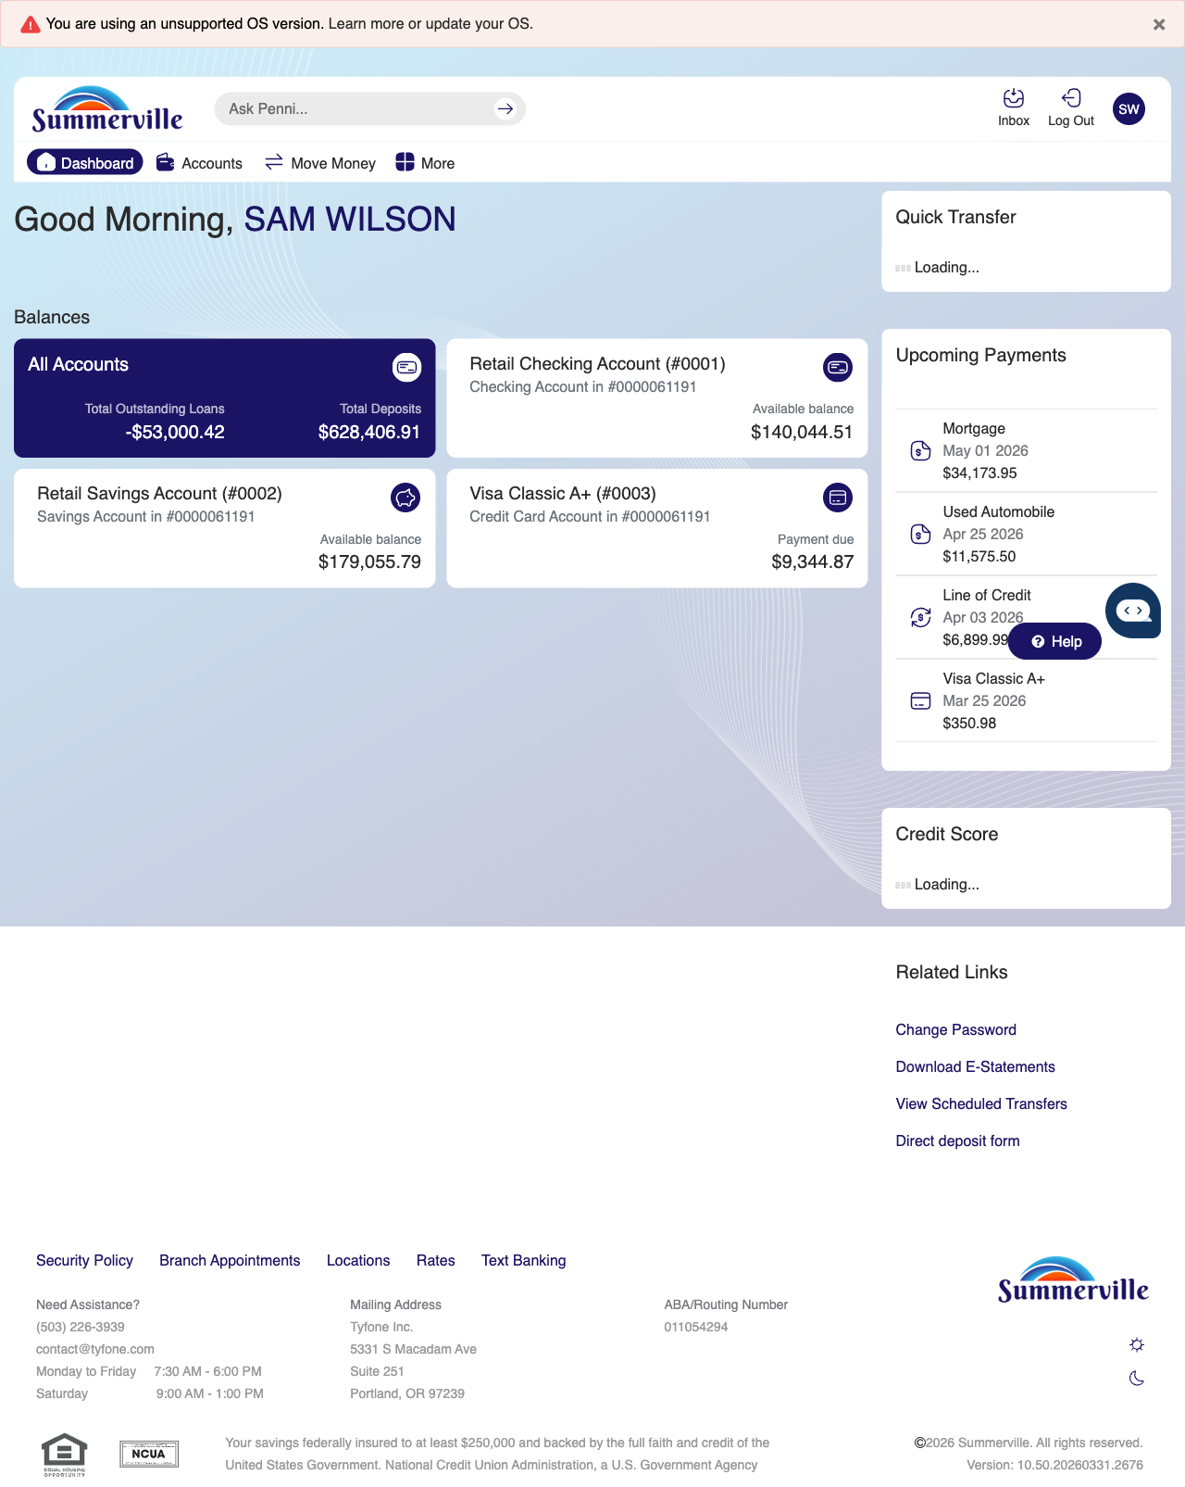
Step 1: Start from Dashboard

Step 2 — Navigate to Move Money Hub
The member clicks ‘Move Money’ in the top navigation bar. The Move Money Hub displays all payment and transfer options as tiles including Pay Bills, Quick Pay, Zelle Payment, Internal Transfers, Other Members, Same-Day Transfers, Send Instantly, Manage Recipients, Add Recipient, Transaction History, Scheduled Transfers, and P2P Transfer.
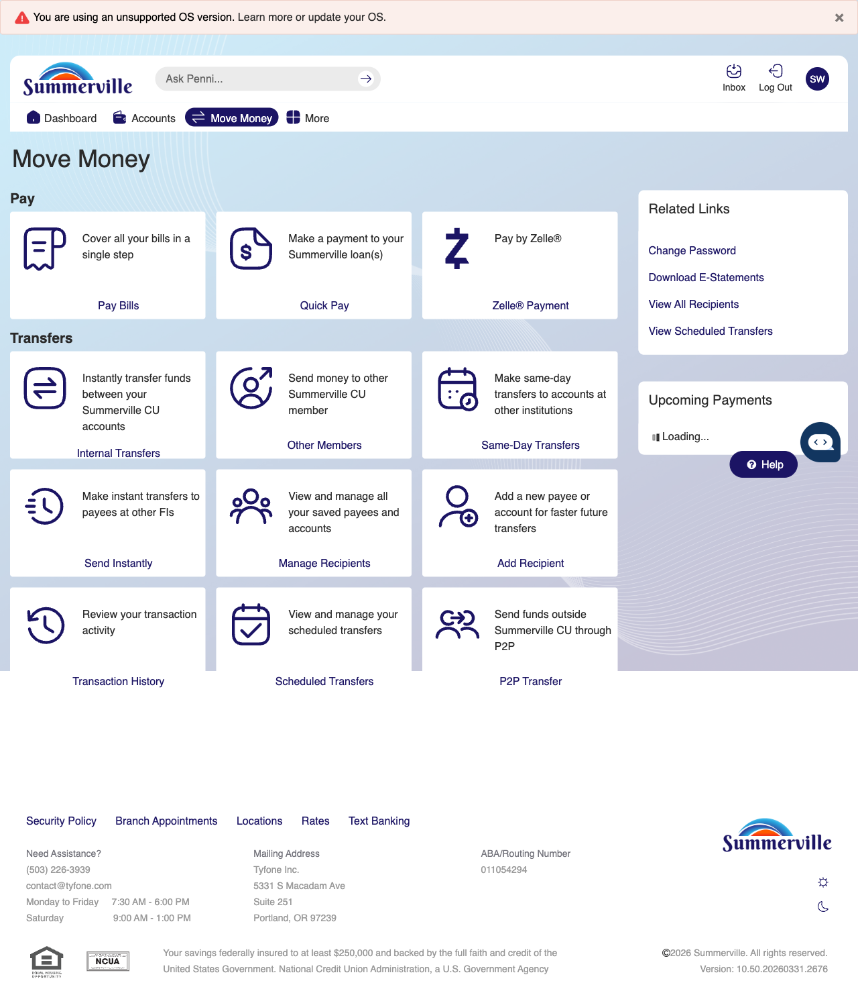
Step 2: Move Money Hub

Step 3 — Open the Wire Transfer Form
The Domestic Outgoing Wire Transfer Request form is displayed within the Online Forms section, showing the form title and multiple input fields for initiating a wire transfer request.
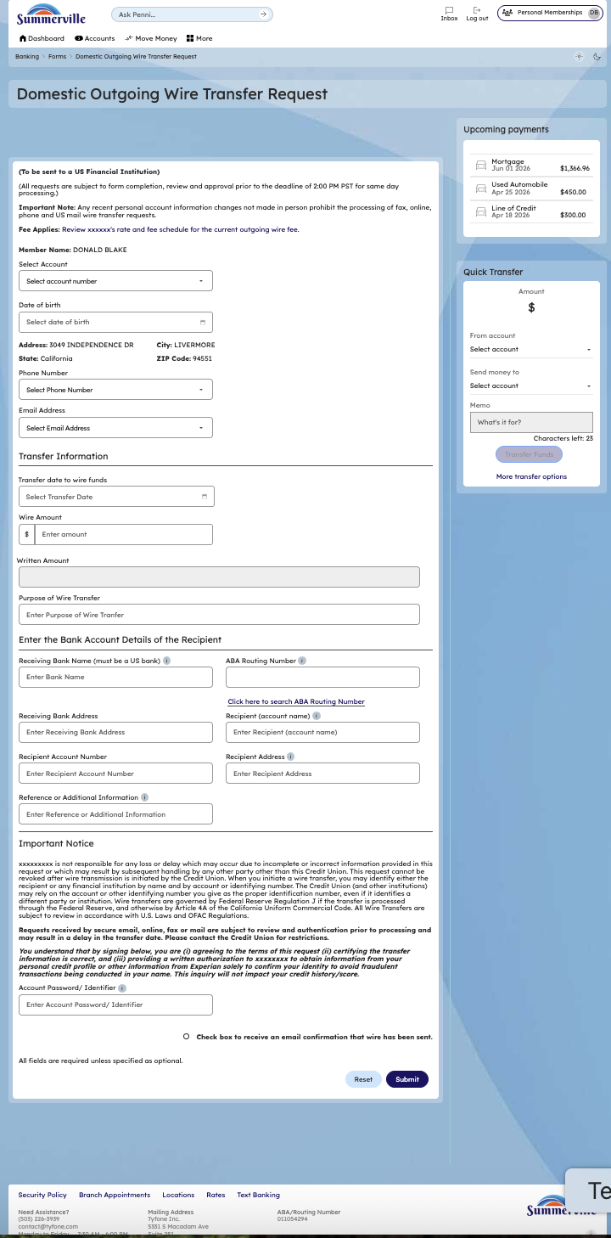
Step 3: Open the Wire Transfer Form

Step 4 — Review & Submit
The Forms list page is displayed showing all available form types. The member can review the submitted wire transfer status or access other form types such as ACH Origination, Address Change, Card Order, and more from this screen.
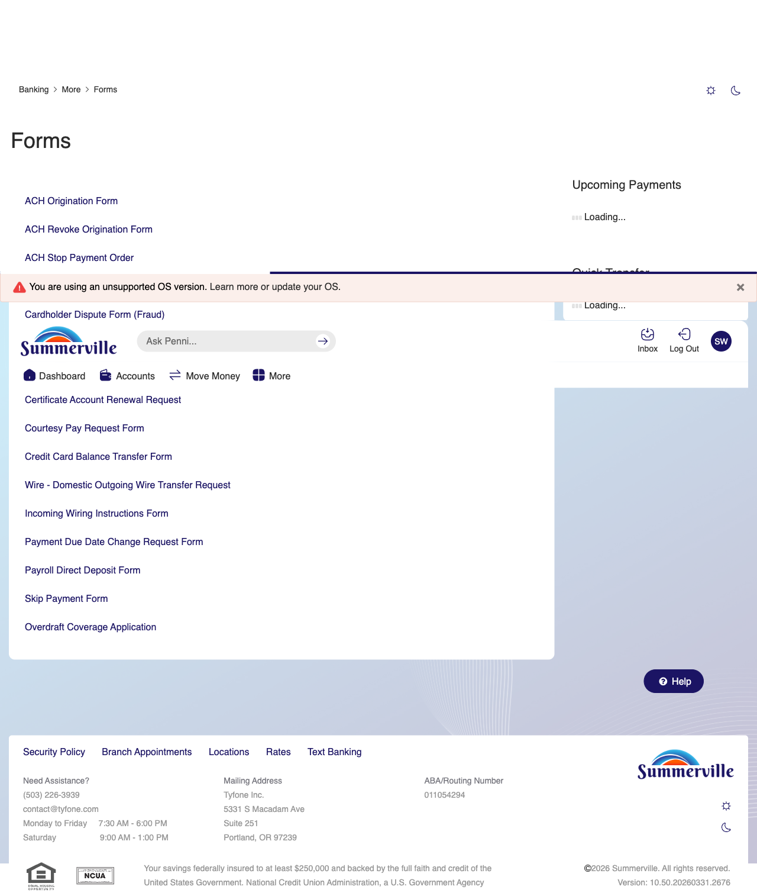
Step 4: Review & Submit

